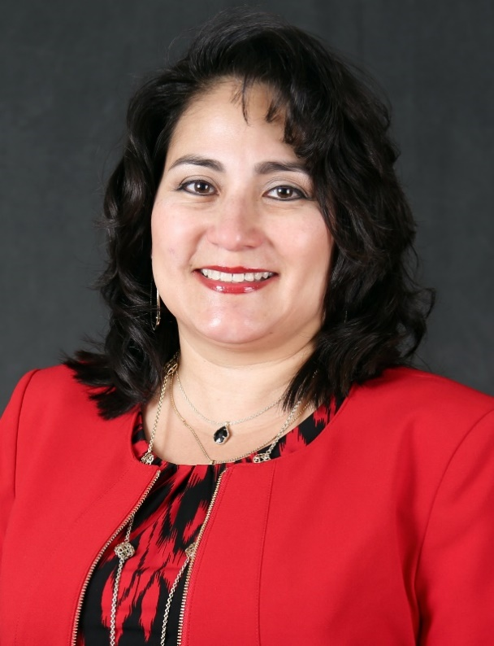
Dr. Claudia Otto
Dr. Claudia Otto worked for 11 years at the secondary level as a special education English teacher for grade levels 9-12, serving various mild/moderate disabilities. There, she facilitated the success of her students, employing a range of strategies and approaches, collaborating with families to help them support their children, and working with general educators and other related services agency staff to coordinate students’ academic programs. The bulk of her K-12 experience was in a high school that served a very diverse population including Hispanic, Native American and African American groups. Dr. Claudia Otto also served for 2 years as the Disability Services Specialist for the Oklahoma Department of Career and Technology Education. There, she provided training for career and technology education instructors, guidance personnel, and student services staff that teach or advise students with identified special needs or other circumstantial needs requiring specialized or individualized attention. Currently, Dr. Otto is a Clinical Assistant Professor with Oklahoma State University, working on both the Stillwater and Tulsa campuses. She has been teaching at the university level since 2011. Teaching both graduate and undergraduate special education courses that include instructional design and methods, social education processes, transition services, and interagency collaboration. Otto draws on her experience as a secondary special education teacher to enhance course content and increase relevance. Simultaneously, she serves on various agency and state boards and committees that support children and adults with mild-moderate disabilities. Being of Mexican descent, Dr. Otto had a unique understanding of the cultural perspective of many of her minority students and their families. This perspective fueled her efforts to make school accessible and open to them. To encourage a positive and effective relationship with families, she taught conversational English to the families and provided information on how the special education system worked so that they could better advocate for their children. In addition to her extensive experience working with secondary and post-secondary students to meet their educational needs and assisting them with the post-secondary preparation, she strives to ensure that learning is accessible in an equitable, appropriate, and fair manner to the student population at large.

